- Purpose

The purpose of this procedure is to describe how to determine the percent solids of slurry product.

- Scope

This procedure applies to all in-coming slurry products to the QA Laboratory.

- Responsibility

Lab Associate is responsible for testing all slurry products.

- Safety Considerations

Appropriate PPE is to be worn in the laboratory.

Safety is a condition of employment. Employees are not authorized to work in an unsafe manner and are prohibited from harming the environment of the facility or the community.

- Materials/Equipment

- Weighing balance -- B440 Satorius
- Gardner cup with lid

- Procedure

Record the following data on forms Slurry Testing (L12-FM-200-009) or Tetra Slurry Testing (L12-FM-200-010).

- After recording data from slurry sample bottle shake sample until all settling has re-suspended.
- Place empty Gardner cup with lid on balance and tare to zero.
- Remove cup from balance, remove lid and fill cup to just below the top edge.
- Replace lid on cup evenly.
- Excess slurry should seep out the hole in the lid, if no slurry comes out hole then remove lid and add more slurry.
- Wipe excess slurry off the cup and place back on the balance.
- For Gabbs, Superior and Aspers use the exact sequence of the following formula for solids results:

weight (g) ÷ 10 – 7.20 ÷ 95% x 10 = % solids
Example: 128.20g ÷ 10 – 7.20 ÷ 95% x 10 = 59.16

8. For Martin Marietta (MM) and Tetra material divide the weight by 10 and use the % solids chart.

% SOLIDS CHART

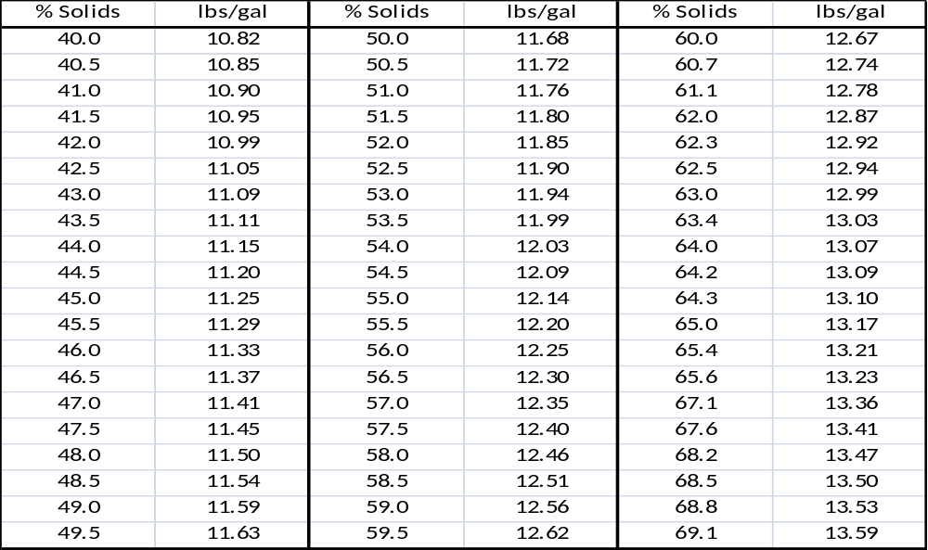

- Reference Documents

Slurry Testing (L12-FM-200-009)
Tetra Slurry Testing (L12-FM-200-010)

- Change Information

Updated procedure using SOP Template Instructions (Q12-PR-100-004) and Document Numbering (Q12-PR-100-003)

